**Name :Karishma Borse**

**Topic : KNN Classification**

**Section 1: Solve 7.2**

**Question a:**

AS displayed in the highlighted area the as per the Y predictions the customer will not take a loan.

Since the y_Prediction value is 0.

**Question b:**

I tried to use different values of K. When K= 1 accuracy = 96.25 %

When the K= 14 , accuracy = 95.58 %

Which is less than k=1.



Hence for the higest accuracy K=1, K=3 gives optimum solution.

**Question c:**

Confusion Matrix using the best k.

**Question d:**

The best values of prediction for the customer is k=5 with accuracy rate = 95.95 %.



**Question e:**

When the data set is splitted into 3 sets – Training set , Validation set and Test set . Using Trainig dataset the “Classifier_new “ object is trained, using that object, values are predicted. New confusion matrix is created named as cm_new. This data set is using K=3, since this value of K gives the highest accuracy. Accuracy for this model is 95.58 %.

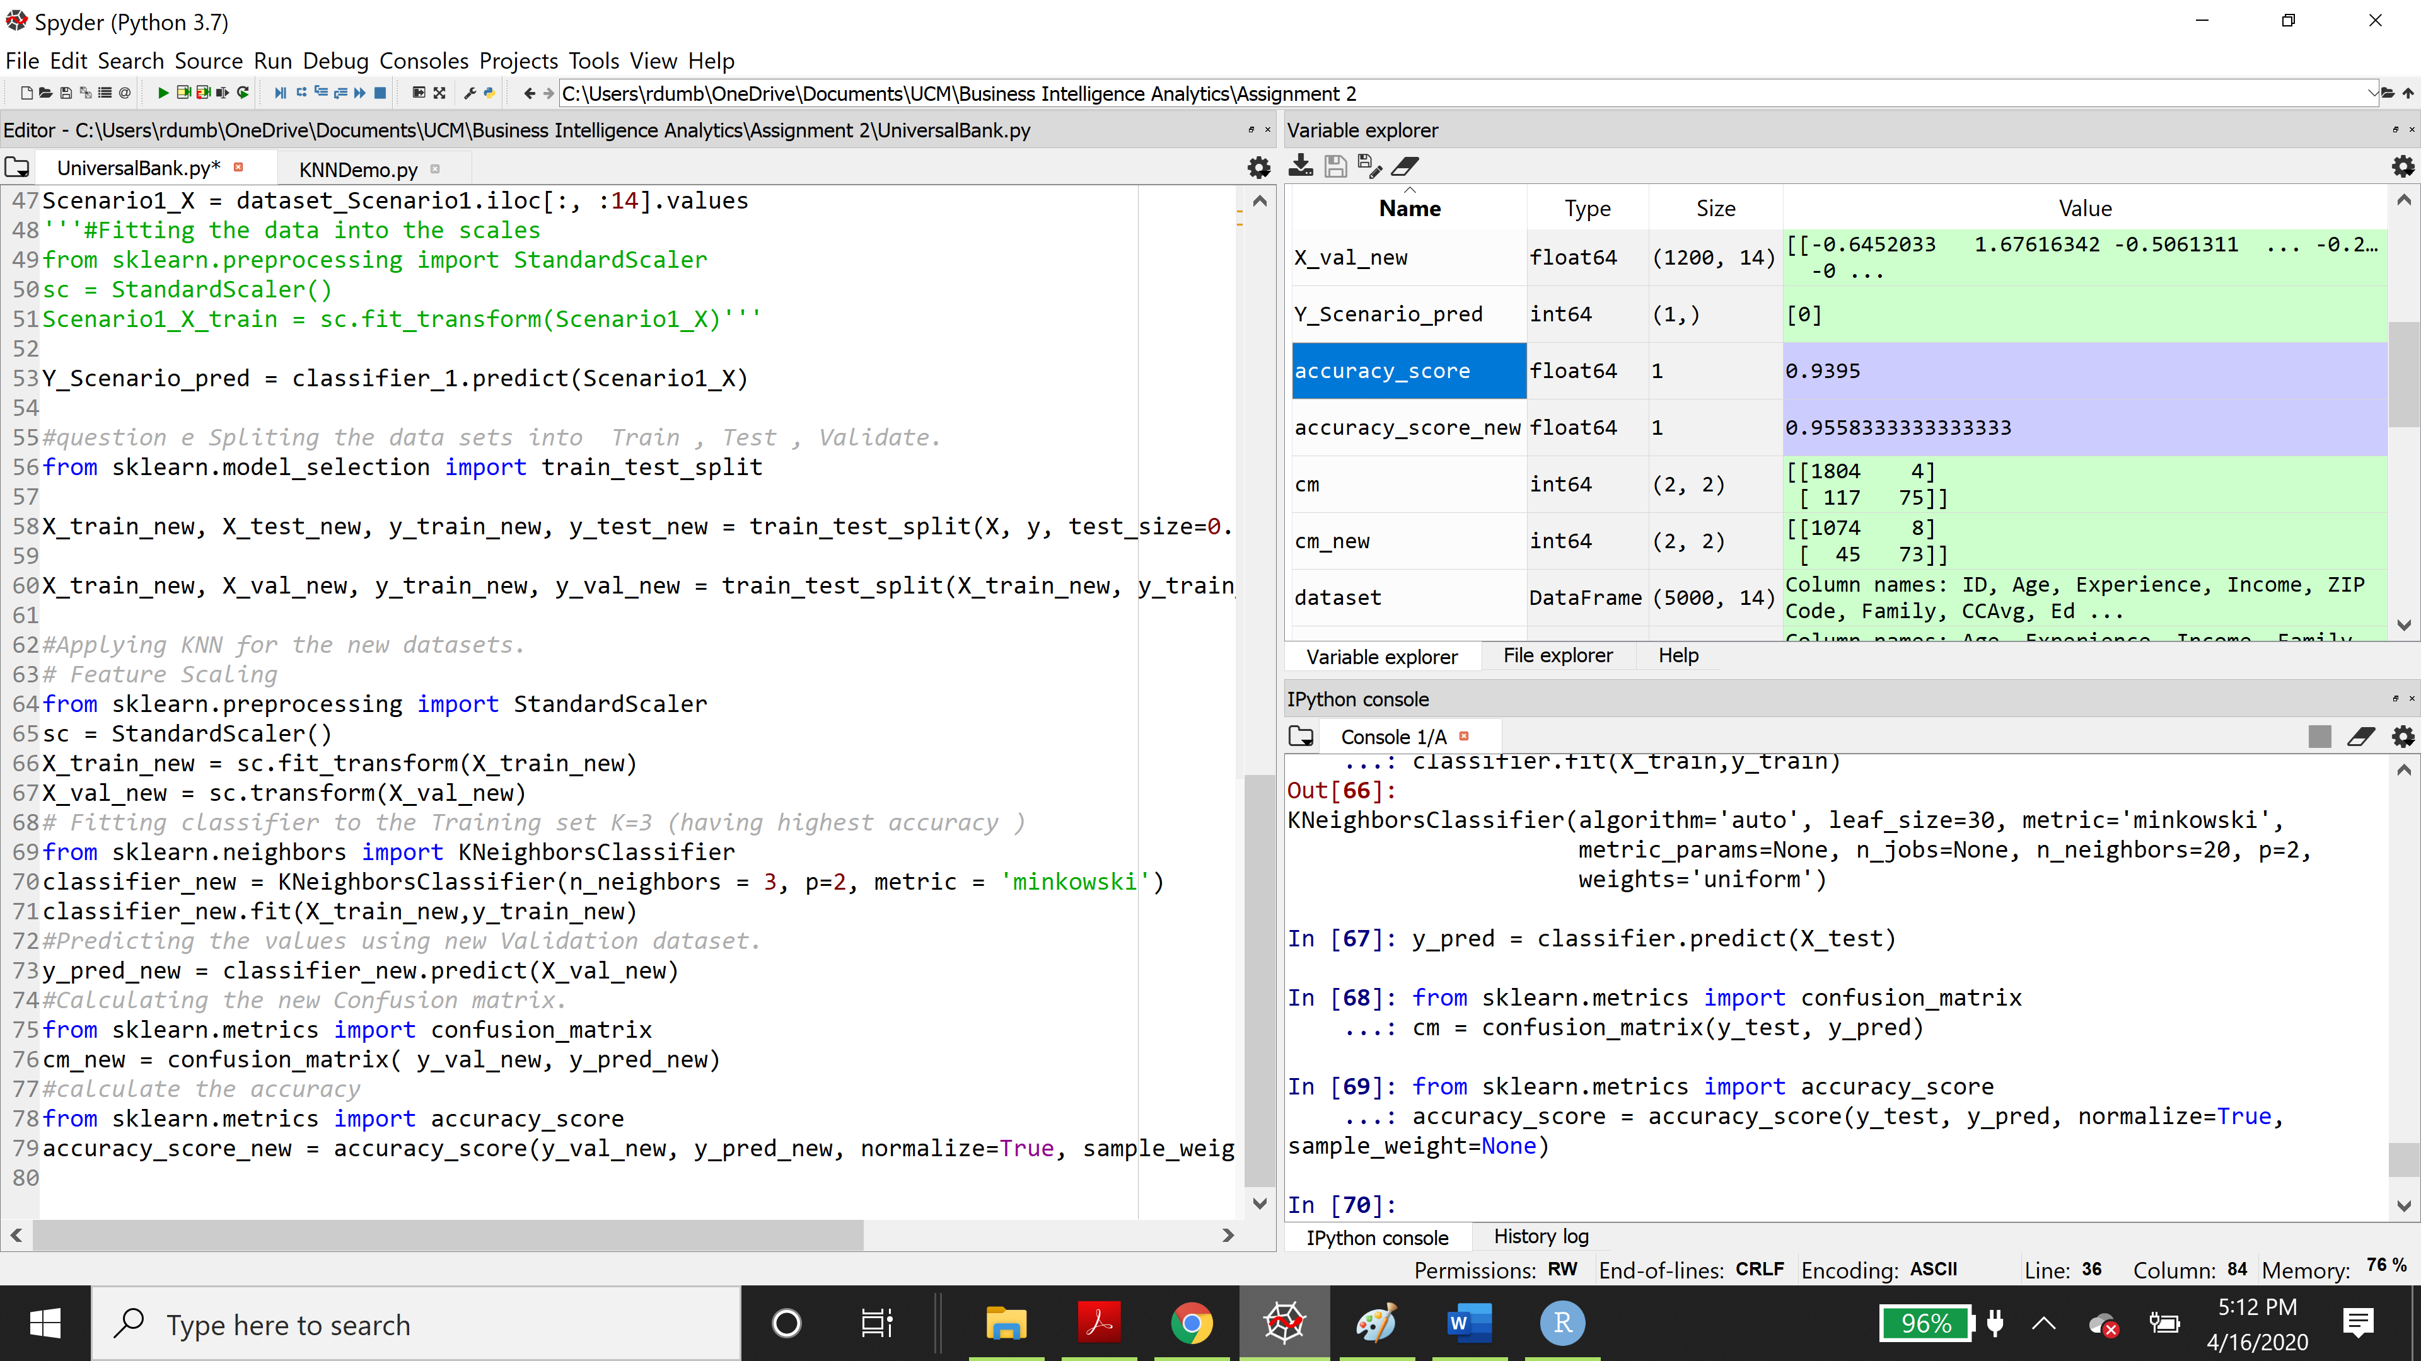



The confusion matrix for this dataset is as follows

**Prediction Code in R:**

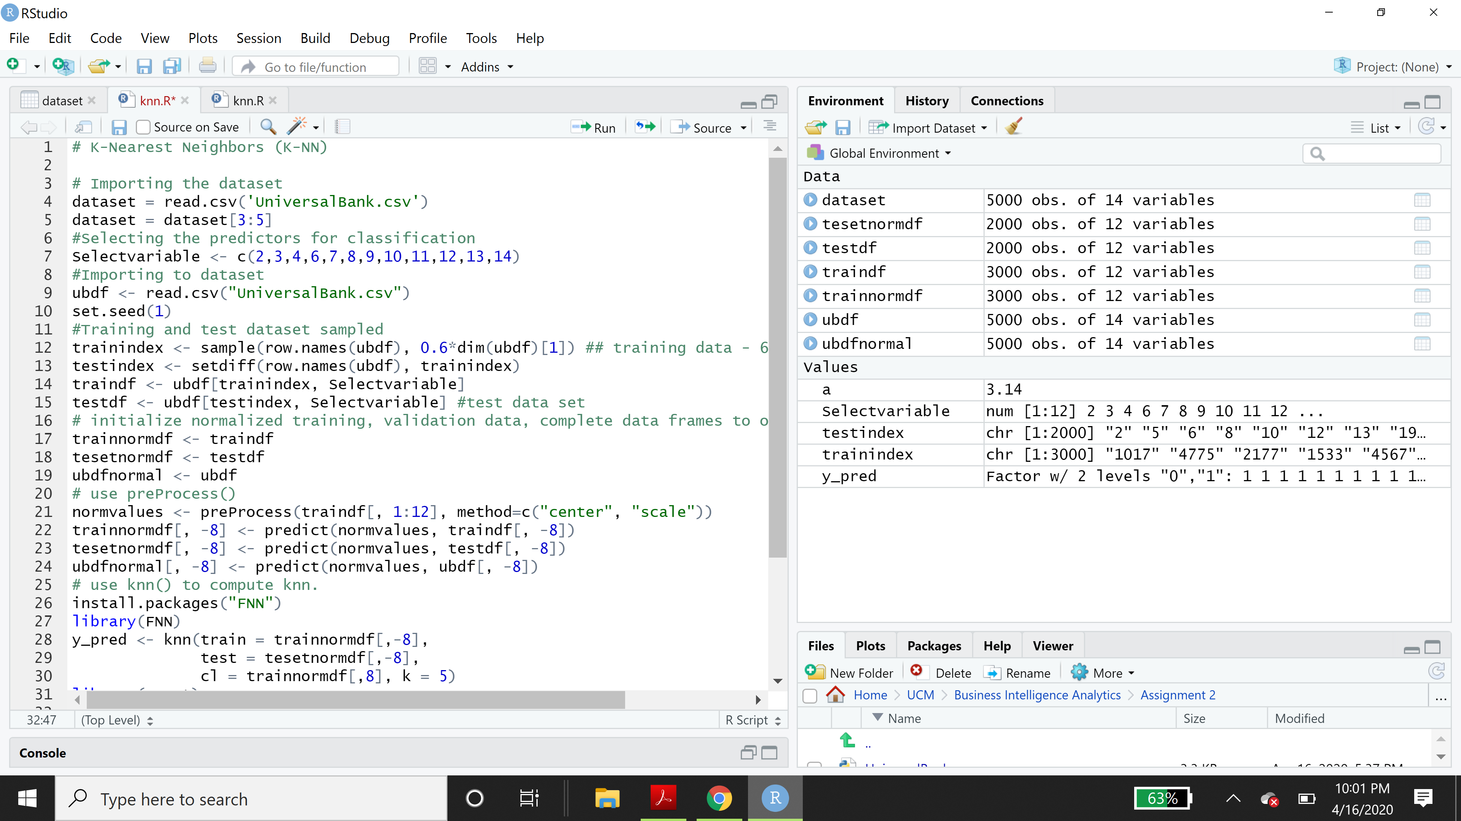

**Section 2: Templates**

**Python Template:**

**R Template:**

